DA SEM

Type |  | Performance Highlights

Key-Value Stores |  | - High performance for simple queries (get/put operations).  - Excellent for read/write-heavy workloads.  - Limited querying and indexing capabilities.

Document Stores |  | - Optimized for read-heavy and write-heavy workloads.  - Support for indexing improves query performance.  - Flexible schema allows easy updates, but queries across collections may be slower than relational databases.

Column-Family Stores |  | - Highly scalable for large datasets.  - Optimized for analytical queries and wide-column reads.  - Write-heavy operations are efficient, but queries involving unrelated columns may degrade performance.

Graph Databases |  | - Efficient for relationship-heavy queries.  - Query performance remains consistent with growing relationships due to optimized graph traversal algorithms.  - Slower for non-relational data queries compared to other types.

UNIT 1:
Explain Profile of Data Scientiest. Provide set of skills they possess and behavioral characteristics
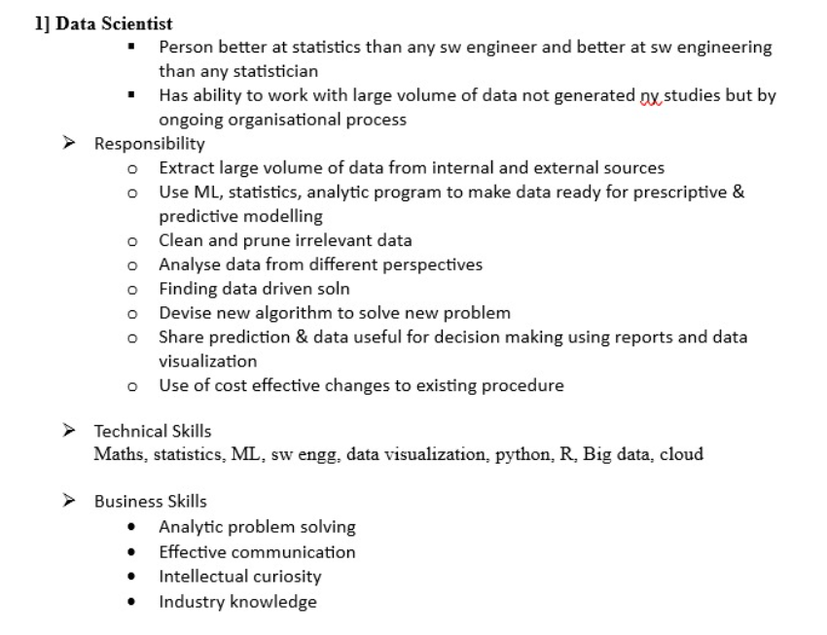
What is multiple linear regression?State how to use multiple regression with formula
Multiple linear regression is used to estimate the relationship between two or more independent variables and one dependent variable.

Multiple linear regression formula
The formula for a multiple linear regression is:
- = the predicted value of the dependent variable
- = the y-intercept (value of y when all other parameters are set to 0)
- = the regression coefficient () of the first independent variable () (a.k.a. the effect that increasing the value of the independent variable has on the predicted y value)
- … = do the same for however many independent variables you are testing
- = the regression coefficient of the last independent variable
- = model error (a.k.a. how much variation there is in our estimate of )
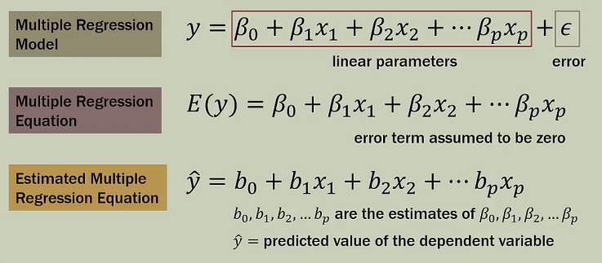

Explain typical Analytical Architecture:
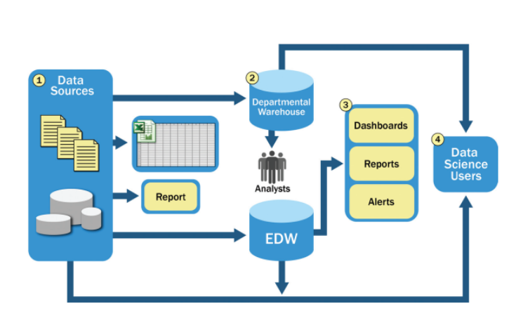

Data Sources
- Data Understanding: Essential to comprehend the purpose and structure of the data, including the meaning of each column and data type.
- Structured and Normalized Data: Data should be formatted consistently (e.g., uniform date formats, proper numeric values).
- Data Type Definitions: Every data element must have a defined type (e.g., integer, string, date) for correct processing.
- Significant Preprocessing Required: Extensive cleaning and preparation are needed to make data usable for analysis.
- No Exploration or Analytics: Focused solely on preparing data, not analyzing it.

Departmental Warehouse
- Flexible Analysis: A separate warehouse allows users to conduct detailed and unrestricted analysis.
- No Constraints: It operates without the limitations of the main data warehouse, enabling deeper data exploration.
- Isolated and Not Synchronized: Operates independently, which may cause inconsistencies with the main warehouse data.

Data Warehouse
- Data for BI and Reporting: Houses data primarily for Business Intelligence applications and report generation.
- High-Priority Applications: Supplies the most critical and accurate data for essential reporting tools.

Data Received by Analysts
- Offline Analysis: Analysts work with data extracts from the main warehouse, analyzing offline on personal systems.
- Limited Tools: Analysis is restricted by the computing power and tools available on their desktops.
- Rarely Shared Results: Insights from these analyses are not typically integrated back into the main data warehouse.
What is the role of Sampling in Data Analytics and explain the various sampl ing designs.
Sampling is a technique used to select a smaller portion (sample s) from a large dataset N to represent the entire dataset.
The main goal of sampling is to make data analysis faster and more manageable without needing to process the entire dataset.

Why Sampling is Useful:
Efficiency: When you have a very large dataset, running algorithms on the entire dataset can be slow and computationally expensive. By working with a smaller, representative sample, you can significantly reduce the time and resources needed for analysis.
Complexity: Sampling allows some algorithms to run more efficiently, with complexity that is potentially sub-linear to the size of the data, meaning the time it takes to run doesn’t increase as quickly as the size of the data does.

Sampling Designs:

1. Simple random sampling
In simple random sampling, every data point in the dataset has an equal chance of
being selected. This method is straightforward and easy to implement. Equivalently,
all samples of size n have an equal chance of being selected. Random samples are
obtained either by sampling with replacement from a finite population or by sampling
without replacement from an infinite population.
Sampling without replacement
Once object is selected then it is removed from the population
Sampling with replacement
Once object is selected then it is not removed from the population

2. Systematic sampling
Systematic sampling is a method of sampling where you select items from a larger
population at regular intervals. It&#39;s a straightforward and efficient way to create a
sample when the data is ordered in some way.

every kth item of the sampling frame is selected, starting from the first element which
is randomly selected from the first k elements

3. Stratified sampling
Population is divided into mutually exclusive groups and random samples are drawn from each group. Divide the population into sub groups (called strata) and based on relevant characteristics (eg: gender, age range, income bracket, job role etc)

Mutually exclusive means If one particular element is present in one group then it cannot be part of other group

4. Proportional sampling
It is used to create a sample that accurately reflects the various subgroups within a larger population. Heres how it works in simpler terms:
1. Divide the Population: First, the entire population is divided into different groups, called strata. Each stratum represents a specific characteristic, like age, gender, or income level.
2. Proportional Selection: Once the groups are formed, a sample is taken from each group. The number of items or individuals selected from each group is proportional to the groups size in the overall population. For example, if one group makes up 20% of the population, 20% of the sample will come from that group.
3. Random Selection: Within each group, the individuals or items are chosen randomly. This helps ensure that the sample is unbiased and representative of each subgroup.

5.Cluster sampling is a method used to create a sample from a larger population by grouping the population into clusters, then randomly selecting some of these clusters for study. Heres how it works in simple terms:
1. Group the Population into Clusters: The entire population is divided into smaller groups called clusters. Each cluster is like a mini-version of the whole population, with a mix of different characteristics, like neighbourhoods in a city or schools in a district.
2. Randomly Select Clusters: Instead of picking individuals from every group, only a few clusters are randomly chosen for the sample.
3. Choose the Sample from Clusters: Once the clusters are selected, you either include all the individuals or items from those clusters in your sample, or you randomly select a certain number of individuals from each chosen cluster.

What is resampling?State and explain different resampling methods.
Resampling is a statistical technique used to estimate the population parameter (such as the mean or proportion) by repeatedly sampling from the data you already have.

How Resampling Helps:

- Understanding Variability: After resampling, you might find that the average scores in your 1,000 samples range from 72 to 78. This range shows you the variability in your estimate and helps you understand that the true average score for all students in the school is likely somewhere within this range.
- Building Confidence: By looking at the distribution of these 1,000 estimates, you can create a confidence interval. For example, you might say that you’re 95% confident that the true average score of all students falls between 73 and 77. This gives you a more informed and reliable understanding of the population parameter than relying on the single estimate of 75.

Different statistical re-sampling methods
1.Bootstrap Resampling:
Explanation: In bootstrap resampling, you repeatedly draw samples from your original dataset, but with a twist—you sample with replacement. This means that after selecting an item, it goes back into the pool and can be picked again, so the same item might appear more than once in a single sample.
Real-Life Example:
Scenario: Imagine youre a baker trying to estimate the average weight of cookies you bake. You have a batch of 100 cookies, and you randomly select 10 cookies to measure their weight. In bootstrap resampling, you might select one cookie, measure its weight, put it back in the batch, and then pick another (possibly the same cookie again). You do this until you have a sample of 10 cookies.
Purpose: By repeating this process many times, you generate multiple samples of 10 cookies each. This helps you understand how much the average weight might vary and gives you a better estimate of the true average weight for all the cookies you bake.

2.k-fold Cross-Validation:
Explanation: In k-fold cross-validation, you divide your dataset into k equal parts or folds. You then train your model on k-1 folds (using them as the training set) and test it on the remaining fold (the test set). This process is repeated k times, with each fold being used as the test set once. The performance of the model is then averaged across all k trials.
Real-Life Example:
o Scenario: Suppose youre a teacher evaluating a new teaching method. You have test scores from 100 students and want to predict future student performance. You divide the students into 5 groups (k=5). You then train your model on 4 groups and test it on the 5th group to see how well your model predicts their scores.
o Purpose: You repeat this process 5 times, each time using a different group as the test set and the remaining groups as the training set. By the end, you have 5 test results, which you can average to assess the overall accuracy of your prediction method. This helps ensure that your model is not just working well on one specific group of students but is generalizable to all students.

Difference between sampling and re sampling
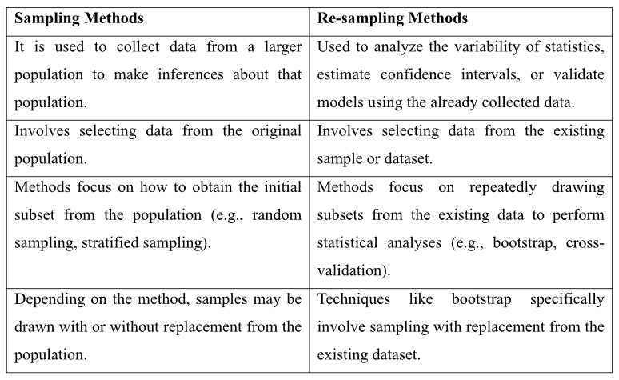

Difference between supervised and unsupervised learning
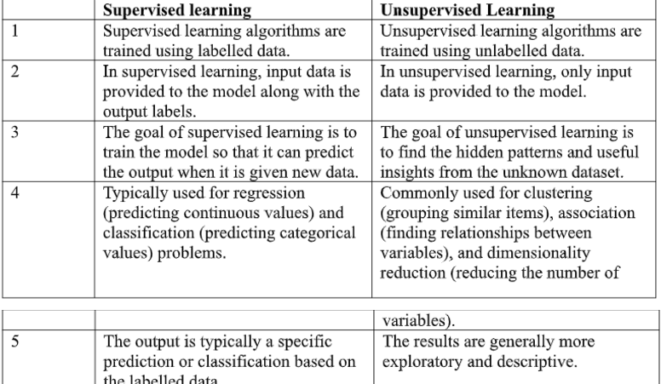
Important characteristics of Big Data used in Analytics
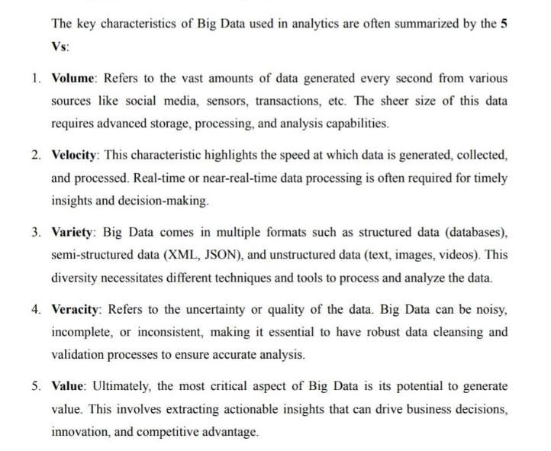
Explain necessity of combining several algos for accomplishing particular task.
- Improved Accuracy: Combining models averages out their errors, leading to better predictions.
  - Example: Random Forest improves accuracy by combining decision trees.
- Reduced Variance and Bias: Bagging reduces overfitting (variance), while boosting reduces underfitting (bias).
  - Example: Bootstrap aggregating smoothens predictions.
- Handling Complexity: Different models address different aspects of a problem.
  - Example: CNNs extract image features, while SVMs classify them.
- Increased Robustness: Multiple models compensate for each other's errors.
  - Example: Fraud detection systems use diverse models for reliability.
- Diverse Learning: Combining models tackles noise, missing data, and imbalances better.
  - Example: Anomaly detection benefits from both rule-based and ML approaches.
- Multi-Modal Data: Specialized models process different data types together.
  - Example: Combining text analysis with X-ray image models for medical diagnosis.
- Better Generalization: Ensembles catch patterns that a single model might overlook.
  - Example: Stacking uses multiple base models and a meta-model for stronger predictions.
- Compensating Limitations: Leveraging the strengths of various algorithms.
  - Example: KNN works well with small datasets, while linear models are faster for larger ones.

UNIT 2:

Bagging:

- Bagging creates multiple versions of the training set by randomly sampling with replacement. This means that some data points may appear multiple times, while others might be left out.
- Training Different Learners: Each learner (model) is trained on a different version of the training set, and in the end, we combine their results, usually by voting.
- Bagging helps to reduce this instability by combining multiple models trained on different samples of the data.
- Example: If you train a decision tree on slightly different subsets of data, you might get very different results. By using bagging, we average out these results, making the model more robust.
- For Regression and Classification: Bagging can be used for both classification problems
(e.g., deciding if an email is spam or not) and regression problems (e.g., predicting house prices). The final prediction is the average or majority vote of the models.

Boosting:

- Boosting is an iterative process where we train weak models (models that aren’t very strong) sequentially. Each model tries to correct the mistakes made by the previous ones.
- Focus on Misclassified Data: After each model is trained, Boosting gives more importance to the data points that were classified incorrectly by earlier models, forcing the new model to focus on these harder cases.
- Example: Imagine you’re training a model to classify animals in pictures. If your first model misclassifies some cats as dogs, the next model will focus more on these specific pictures to get them right.
- Boosting Procedure:
Step 1: Start by training a model on the entire dataset with equal weights for all
observations.
Step 2: Identify where the model makes mistakes and increase the weight
(importance) of these misclassified data points.
Step 3: Train a new model that focuses on correcting these mistakes.
Step 4: Continue this process for several iterations until the model improves its
accuracy.

Aspect | Bagging | Boosting
Data Partition | Data is randomly split into subsets, and each subset is used to train a different model. | Misclassified data points are given higher importance after each round of training.
Goal | Reduce the variance of the model (i.e., reduce overfitting). | Increase the accuracy of the model by focusing on misclassified data.
Method | Uses random sampling. | Uses methods like gradient descent to improve accuracy.
Function | Combines model outputs by voting or averaging. | Uses a weighted voting method, giving more importance to models that performed better.

Naive Bayes Theorem:
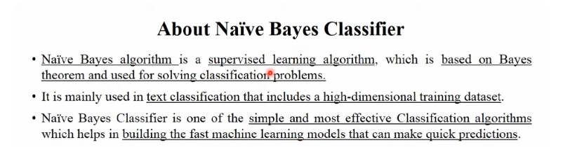
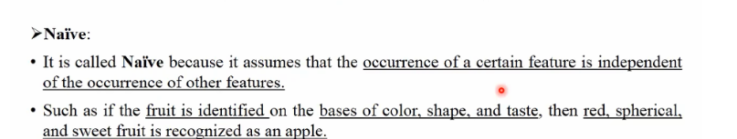
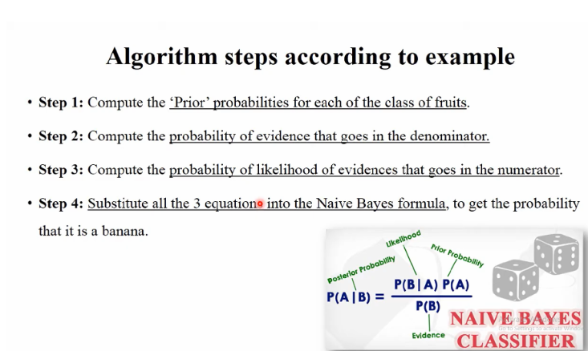
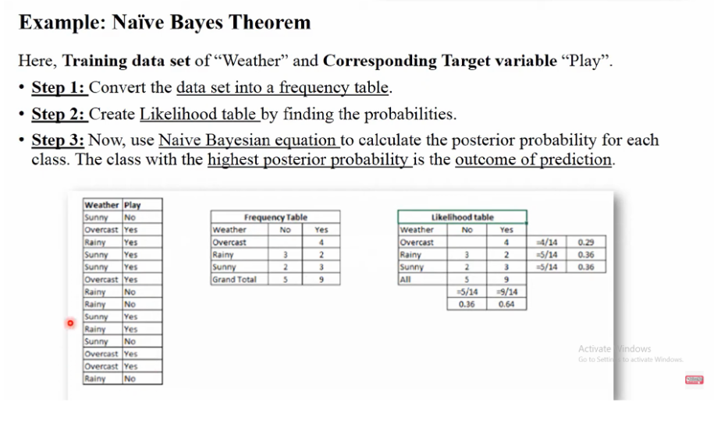
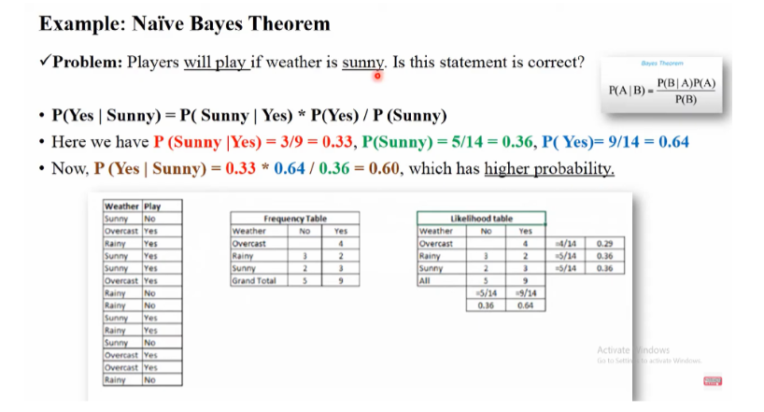
Advantages:
- Fast and easy to predict class of datasets
- Used for binary as well as multiclass classification
- Popular choice for text classification

Disadvantages:
- Assumes that all features are independent or unrelated.So cannot learn relationship about features.
Applications:
- Used for credit scoring
- Used in medical data classification
- Object and face detection
- Used in text classification such as spam filtering and semantic analysis
- Recommendation system

Understanding Entropy and Information Gain

1. Entropy:
Entropy (H(S)) is a measure of uncertainty or randomness in data. It quantifies how unpredictable an event is. Lower entropy means less randomness (more predictability), while higher entropy means more randomness (less predictability).
Examples:
- Fair coin toss:
Probabilities: Heads = 0.5, Tails = 0.5
Entropy is high because the outcome is completely uncertain.
- Biased coin (two heads):
Probabilities: Heads = 1, Tails = 0
Entropy is zero because there is no uncertainty; the result is always heads.

2. Information Gain (IG):
Information gain measures the reduction in entropy after splitting a dataset based on a feature. It helps determine which feature provides the most useful information for classification.
Formula:
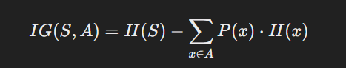
- H(S): Entropy of the entire set
- P(x): Probability of an event
- H(x): Entropy of the subset after splitting by feature A

Building a Decision Tree Using Entropy and Information Gain
A decision tree uses these concepts to choose the best feature to split the dataset at each step. It selects the feature with the highest information gain, as this split reduces uncertainty the most.
Example:

| Weather | Go Outside |
|-----------|------------|
| Sunny | Yes |
| Sunny | Yes |
| Rainy | No |
| Rainy | No |
| Overcast | Yes |

---

Step 1: Calculate Total Entropy ((H(S)))
There are 5 samples:
3 Yes
2 No
H(S) = -(3/5)log2(3/5) - (2/5)log2(2/5)
H(S) =0.971

Step 2: Split by "Weather"
We now calculate the entropy for each weather condition.

- Sunny (2 samples):
2 Yes, 0 No
H(Sunny) = -(2/2)\log2(2/2) - 0
H(Sunny) = 0
- Rainy (2 samples):
0 Yes, 2 No
H(Rainy) = -(2/2)log2(2/2) - 0
H(Rainy) = 0
- Overcast (1 sample):
1 Yes, 0 No
H(Overcast) = -(1/1 )log2(1/1) - 0
H(Overcast) = 0

Step 3: Calculate Weighted Average Entropy
H(Weather) =(⅖ )H(Sunny) +(⅖ )H(Rainy) +(⅕ )H(Overcast)
H(Weather) = (⅖. 0) +(⅖. 0) +(⅕.0)
H(Weather) = 0

Step 4: Calculate Information Gain
IG(S, Weather) = H(S) - H(Weather)
IG(S, Weather) = 0.971 - 0 = 0.971

Conclusion:
Using "Weather" to split the data gives us the highest information gain, so it is the best feature for the first split in the decision tree.

Explanation of Logistic Regression:
Logistic regression is used when the target (dependent) variable is binary or
categorical, like obese (1) and non-obese (0). Instead of predicting the exact value,
logistic regression predicts the probability of an event (e.g., being obese).

Process in Logistic Regression:
The logistic function converts a linear regression output (which can be any value)
into a probability (between 0 and 1).

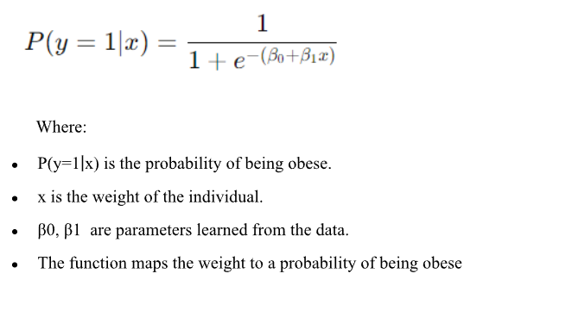
What logistic regression predicts
What is Logistic Regression?
Logistic regression is a statistical method used to predict the probability of an event happening (like an outcome with only two possibilities: yes or no, success or failure).
Key Points:
- Predicting Outcomes:
  - Logistic regression helps us predict whether something will happen or not, based on known factors (independent variables). For example, we might predict whether a person is likely to be diagnosed with a disease (yes or no) based on factors like age, weight, and exercise habits.
- Transforming the Data:
  - In logistic regression, the outcome (yes or no) is transformed into something called the log of the odds (this is also known as the "logit").
  - The odds represent how likely something is to happen compared to not happening.
  - For example, if a doctor says that the odds of getting the disease are 3 to 1, this means it's 3 times more likely to get the disease than not.
- Probabilities and Odds:
  - In the real world, probabilities range between 0 and 1. For example, if there is a 70% chance of rain tomorrow, the probability is 0.7.
  - Logistic regression transforms these probabilities into odds ratios, which can range from 0 to infinity.
  - An odds ratio tells you how much more likely something is to happen compared to it not happening. For example, an odds ratio of 2 means something is twice as likely to occur.
- Cut-off Point:
  - Logistic regression uses a cut-off point to make a prediction. Typically, the cut-off is set at 0.5 (or 50%). If the predicted probability of the event happening is greater than 0.5, we predict that the event will happen. If it’s less than 0.5, we predict the event won’t happen.
  - For example, if a model predicts a 70% chance of rain tomorrow, we would predict that it will rain. If it predicts a 30% chance, we would predict it won’t rain.

Apriori Algo:
Association Mining rule
- Apriori algorithm uses frequent itemsets to generate association rule and it is designed to work on databases that contain transactions.
- With the help of these association rule, it determines how strongly or how weakly two objects are connected.
- It is mainly used for market basket analysis and helps to find out those products that can be bought together.
Steps for Apriori algorithm
1. Determine the support of itemsets in the transactional database, and select the minimum support and confidence.
2. Take all support in the transaction with higher support value than minimum or selected support value.
3. Find all the rules of these subsets that have higher confidence value than the threshold or minimum confidence.
4. Sort the rules as the decreasing order of lift.
Advantages:
- Easy to understand algorithm
- Easily implemented on large datasets
Disadvantages:
- Slow compared to other algorithms
- Overall performance is reduced
- Time complexity and space complexity is high
Applications:
- Market Basket Analysis
- Medical Diagonosis: Helps in identifying probability of illness for particular disease

Explain the SVM Classification algorithm. State its properties, functions and types
Support Vector Machine or SVM is one of the most popular supervised learning algorithm
which is used for classification as well as regression problems.
However, primarily it is used for Classification problems in Machine Learning.
The goal of SVM algorithm is to create best line or decision boundary that can segregate n-
dimensional spaces into classes so that we can easily put the new data point into correct
category in future.
SVM algorithm can be used for face detection, image classification, text categorization etc.

SVM Algorithm Steps
1. Select two hyperplanes (2D) which separates the data with no points between them
(red lines)
2. Maximize their distance (the margin)
3. The average line (here the line half way between the two red lines) will be the
decision boundary.

Key concepts of SVM
Support vectors: Data points that are closet to the hyperplane is called support vectors.
Seperating line will be defined with the help of these points.
Hyperplane- It is a decision plane or space which is divided between set of objects having
different classes.
Margin: It is defined as gap between two lines on the closet data points of different
classes.It can be calculated as perpendicular distance from the line to the support
vectors.Large margin is considered as good margin and small margin is considered as bad
margin.

Types of SVM
Linear SVM: It is used for linearly seperable data. Which means if a dataset can be classified
into two classes by using single straight line such data is termed as linearly seperable data.
And classified used is called as linear SVM classifier.

Non-linear SVM: Non-linear SVM is used for non-linearly seperable data, which means if a
dataset cannot be classified using straight line, then such data is termed as non-linear data and
classifier used is called as Non-linear classifier.

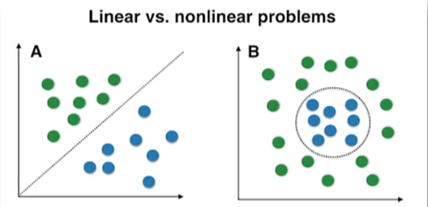

K-means clustering
- A K-means algorithm tries to group similar items in the form of clusters.
- The number of groups is represented by k. if K=2 then there will be two clusters
- It is a centroid based algorithm where each cluster is associated with centroid
- The main aim of the algorithm is to minimize the sum of distances between the data points and their corresponding cluster
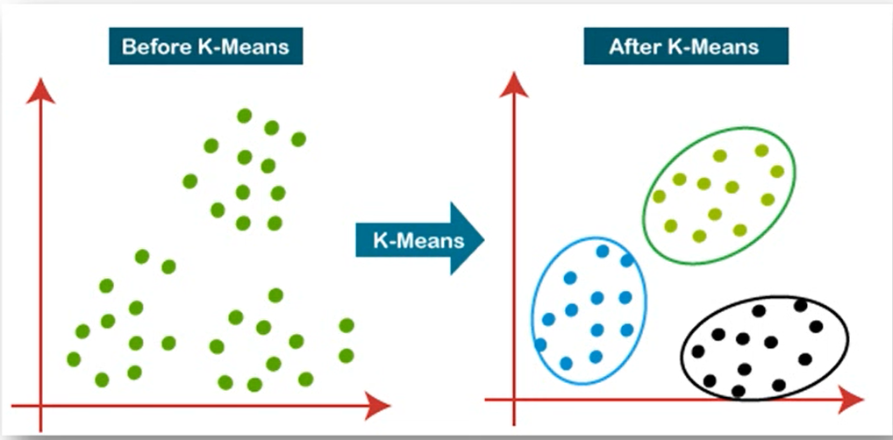
K-means algorithm steps
- Select number k to decide number of clusters
- Select random K points or centroids. (It can be other from the input dataset).
- Assign each data point to their closet centroid. Which will form a predefined K cluster
- Calculate variance and place new centroid of each cluster.
- Repeat third step, which means reassign each data point to the new closest centroid of each cluster.
- If any reassignment occurs then go to step 4 or else go to finish.
- Model is ready

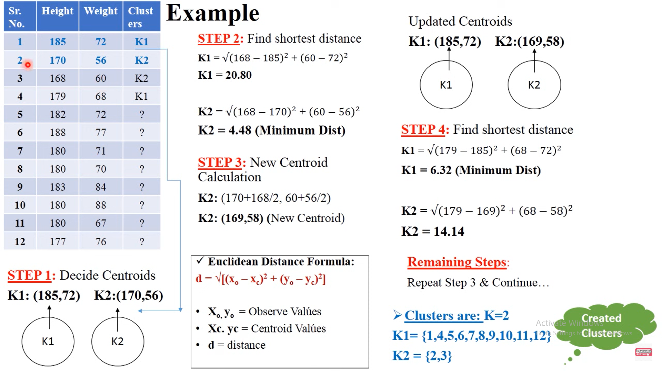

Advantages of K-Means

- It is very simple to implement
- It is scalable to a huge dataset and also faster to large dataset.
- It adapts new examples very frequently
- Generalization of clusters for different sizes and shapes.

Disadvantages of K-Means
- It is sensitive to outliers.
- Choosing the K values manually is a tough job.
- As the number of dimensions increases its scalability decreases.

K- Medoids
K-medoids is a partitional clustering algorithm which is slightly modified from k-means algorithms
In K-means we choose means as a centroids but in k-medoids, data points are chosen to be mediods
K-medoids algorithm
- Initially select k random points as the medoids from the given n data points of the data set
- Associate each data point to the closet medoids by using any of the most common distance metrics.
- Calculate total cost as the sum of the distances of the data points from the assigned medoids
C= $\sum_{ci}{}\sum{}|p_{i}- c_{i}$|
- Swap the one medoid point with non-medoid point and recalculate the cost

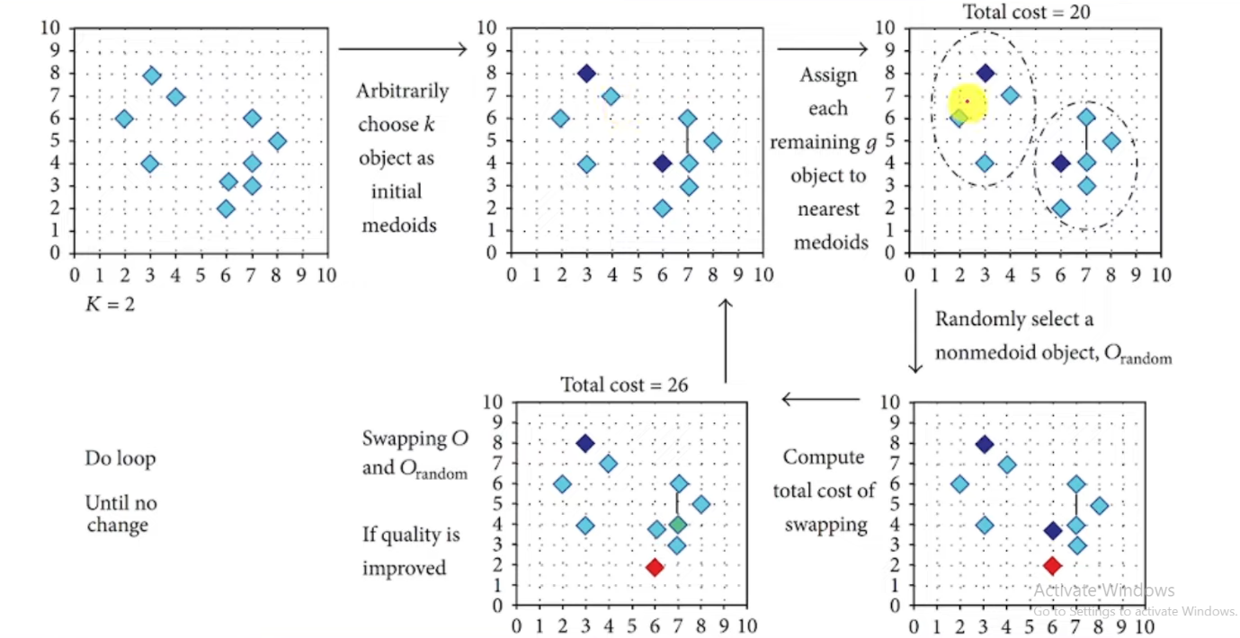
Advantages
- It is simple to understand and easy to implement
- K-medoid algorithm is fast and converges in fixed number of steps
- K-medoid is less sensitive to outliers and partitioning algorithms

Disadvantages
- The main disadvantages of k-medoids algorithm is that it is not suitable for clustering non-spherical(arbitrarily shaped)group of objects
- It may obtain different results for different runs on the same dataset because first k-medoids are chosen randomly

Random Forest:
Random Forest: It is a collection of multiple random decision tree and it’s much less sensitive to the training data. Since we are using multiple trees hence the name forest.
The term "random" in Random Forest (a type of ensemble learning algorithm) refers to two main aspects of randomness introduced during its creation, which improve the model's robustness and reduce overfitting:
(Refer notes for example)

Steps in text analysis Process

Text analytics process typically consist of several steps aimed at extracting
meaningful insights from textual data. Here is brief outline of these steps:

1.Text Preprocessing

Tokenization: Example: The sentence "Text analysis is fun!" can be tokenized into
["Text", "analysis", "is", "fun", "!"].

Lowercasing: Example: Convert "Text Analysis Is Fun" to "text analysis is fun" to ensure
uniformity.

Stopword Removal: Example: From the sentence "Text analysis is fun", remove
common words like "is", leaving ["text", "analysis", "fun"].

Stemming/Lemmatization: Example:

Stemming: "running" becomes "run", "better" becomes "better".

Lemmatization: "running" becomes "run", "better" becomes "good" (reducing words to their
root form based on meaning).

2. Text Representation:

Bag of Words (BoW): Example: For the sentences "I love dogs" and "I love cats", the BoW model
builds a frequency table like:

TF-IDF (Term Frequency-Inverse Document Frequency): Example: For the
word "analysis" that appears frequently in one document but rarely in others,
TF-IDF will assign it a higher weight compared to common words like "is" or
"the".

Word Embedding:

Let’s consider three words: "king", "queen", and "table". In Word2Vec, these
words are mapped into a multi-dimensional vector space, where words with
similar meanings or used in similar contexts will be close to each other in that
space.

"King" might have a vector like: [0.65, 0.33, 0.25, 0.78]

"Queen" might have a vector like: [0.61, 0.35, 0.24, 0.80]

"Table" might have a vector like: [0.12, 0.45, 0.15, 0.34]

Even though these vectors are numerical, we can measure the "distance"
between them, and words like "king" and "queen" will be closer together in the
vector space compared to a word like "table". This distance is calculated using
methods like cosine similarity or Euclidean distance.

For example:

The distance between "king" and "queen" would be small, implying they are
semantically related (both are royalty).

The distance between "king" and "table" would be larger, as these words are
semantically unrelated.

3.Feature Extraction:

Identifying features like word frequency, n-grams (phrases of n words), or parts
of speech to form the basis for analysis.

4.Sentiment Analysis:

Classifying text as positive, negative, or neutral based on the sentiment
expressed.

Often involves rule-based, machine learning, or deep learning models.

5.Topic Modeling:

Discovering the underlying themes or topics in a collection of documents (e.g., using Latent
Dirichlet Allocation (LDA)).

6. Named Entity Recognition (NER):

Identifying proper nouns or specific entities (e.g., people, organizations, locations) in the text.

7. Text Classification:

Categorizing text into predefined labels or groups (e.g., spam vs. non-spam, product reviews, etc.).

Common approaches include machine learning models like Naive Bayes, Support Vector Machines
(SVM), or deep learning models.

8.Text Summarization:

Extracting the most important information or summary of the text while maintaining coherence.

9. Clustering:

Grouping similar texts together based on their content, often using techniques like K-means
clustering.

10. Evaluation:

Assessing the performance of models used in text analysis (e.g., precision, recall, F1-score for
classification tasks).

//Alternate

Text Analysis:
Text analytics refers to the automated process of examining large volumes of text to identify patterns, trends, and insights. Since text data is typically unstructured, it needs to be broken down and organized to make it easier for computers to analyze.

Scenario:
You have customer feedback from an online store, and you want to analyze the text to understand common themes and the overall sentiment.

1. Text Preprocessing:
- Original text: "The delivery was great, but the product quality is terrible!"
- Tokenization: Split the sentence into individual words or tokens: ["The", "delivery", "was", "great", ",", "but", "the", "product", "quality", "is", "terrible", "!"].
- Stopword Removal: Remove common words that don’t add much meaning, like "the," "was," "is," etc.: ["delivery", "great", "product", "quality", "terrible"].
- Lowercasing: Convert all words to lowercase for uniformity: ["delivery", "great", "product", "quality", "terrible"].

2. Text Representation:
- We convert the cleaned text into a Bag of Words model. For simplicity, let's say we have three reviews:
  - "Delivery was quick and product is excellent."
  - "The product quality is terrible!"
  - "Great delivery, terrible product quality."
After processing, we create a matrix of word frequencies for these reviews:
 | delivery | quick | product | quality | excellent | terrible | great
Review 1 | 1 | 1 | 1 | 1 | 1 | 0 | 0
Review 2 | 0 | 0 | 1 | 1 | 0 | 1 | 0
Review 3 | 1 | 0 | 1 | 1 | 0 | 1 | 1

3. Sentiment Analysis:
- The sentiment analysis step identifies whether a review is positive or negative. For instance, "great" and "excellent" are positive, while "terrible" is negative. Based on this, we might classify:
  - Review 1: Positive (because of "excellent")
  - Review 2: Negative (because of "terrible")
  - Review 3: Mixed (has both "great" and "terrible")

4. Topic Modeling:
- Topic modeling can identify themes. In our case, "delivery" and "product quality" are common topics. A topic model like Latent Dirichlet Allocation (LDA) could show two main topics:
  - Delivery-related feedback (appearing in reviews 1 and 3)
  - Product quality-related feedback (appearing in all reviews, especially 2 and 3)

5. Text Classification:
- We can classify these reviews into predefined categories:
  - Category 1: Delivery feedback
  - Category 2: Product quality feedback
  - Reviews 1 and 3 would be classified under both categories, while review 2 focuses more on product quality.

Q.1 Write a short note on statistical hypothesis generation and testing? Jan 2023 7 marks
Statistical Hypothesis Generation and Testing is a critical process in inferential statistics used to make decisions or draw conclusions about a population based on sample data.
1. Hypothesis Generation:
- Definition: Hypothesis generation involves creating assumptions or educated guesses about a population parameter. These assumptions are based on existing knowledge, theories, or preliminary data.
- Types of Hypotheses:
  - Null Hypothesis (H₀): A statement that assumes no effect, no difference, or no relationship in the population. It represents the status quo or the claim to be tested.
  - Alternative Hypothesis (H₁ or Ha): A statement that contradicts the null hypothesis. It represents the outcome the researcher aims to support, suggesting that there is an effect, difference, or relationship.
- Example: In testing a new drug, the null hypothesis might state that the drug has no effect on patients, while the alternative hypothesis would state that the drug does have an effect.
2. Hypothesis Testing:
- Definition: Hypothesis testing is a formal statistical procedure used to decide whether to reject or fail to reject the null hypothesis based on sample data.
- Steps in Hypothesis Testing: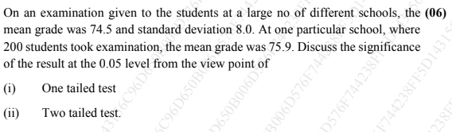
  - Select a Significance Level (α): This is the threshold for determining whether the observed data is sufficiently unlikely under the null hypothesis. Common values are 0.05 or 0.01.
  - Collect Sample Data: Gather data through experiments, surveys, or other methods.
  - Choose a Test Statistic: Depending on the data and hypotheses, select a test statistic (e.g., t-test, z-test, chi-square test) to compare the sample data to what is expected under the null hypothesis.
  - Calculate the Test Statistic and P-Value: Use the sample data to compute the test statistic and determine the p-value, which indicates the probability of observing the data if the null hypothesis is true.
  - Make a Decision:
    - Reject H₀: If the p-value is less than α, reject the null hypothesis in favor of the alternative hypothesis.
    - Fail to Reject H₀: If the p-value is greater than or equal to α, there is not enough evidence to reject the null hypothesis.
- Example: If testing whether a new teaching method improves student performance, and the p-value is found to be 0.03 with α = 0.05, the null hypothesis that the method has no effect would be rejected.
Conclusion: Statistical hypothesis generation and testing provide a structured approach to making data-driven decisions. By systematically evaluating hypotheses, researchers can draw valid conclusions about the population from which the sample was drawn, ensuring that their findings are supported by evidence rather than mere speculation.

Write a short note on T-test Jan 2023 6 marks
The T-test is a parametric statistical test used in hypothesis testing, primarily for comparing the means of a small sample (typically less than 30) to determine if there is a significant difference between them. The test is based on the Student's T-distribution and was developed by William Sealy Gosset, who published his work under the pseudonym "Student."
Key Features of the T-Test:
- Purpose:
  - The T-test is used to assess whether the mean of a sample significantly differs from a known value (e.g., population mean) or whether the means of two samples are significantly different from each other. It is particularly useful when the sample size is small and the population standard deviation is unknown.
- Types of T-Tests:
  - One-Sample T-Test: Compares the mean of a single sample to a known population mean.
  - Independent (Two-Sample) T-Test: Compares the means of two independent samples to see if they are significantly different.
  - Paired (Dependent) T-Test: Compares the means of two related samples, such as the same group of individuals tested before and after an intervention.
- Assumptions:
  - Normality: The population from which the sample is drawn is assumed to follow a normal distribution.
  - Independence: The observations in the sample are random and independent of each other.
  - Unknown Population Standard Deviation: The test is applicable when the population standard deviation is not known, making it distinct from the Z-test, which requires this information.
- Application and Importance:
  - The T-test is essential for testing the significance of mean values in situations where sample sizes are small. It allows researchers to make inferences about a population based on a sample, even when limited data is available.
  - It is widely used in various fields such as medicine, social sciences, and economics, where sample sizes often cannot be large due to practical constraints.
- Example:
  - Suppose a pharmaceutical company wants to test if a new drug affects blood pressure levels. A T-test can be used to compare the mean blood pressure of patients before and after taking the drug. If the sample size is small and the population standard deviation is unknown, a paired T-test would be appropriate.
Conclusion:
The T-test is a robust statistical tool for hypothesis testing, particularly suited for small sample sizes where the population standard deviation is unknown. It enables researchers to draw meaningful conclusions about population means, provided the assumptions of normality and independence are met. This makes the T-test a cornerstone of inferential statistics, especially in fields where data collection is limited or costly.

PROBABLITY OF ERROR

Q.3 Explain briefly ANOVA Test? Jan 2023 6 marks
Analysis of Variance (ANOVA) is a powerful parametric statistical test used in hypothesis testing to compare the means of three or more groups. Developed by Ronald Fisher, it is also known as Fisher's ANOVA. The test is particularly useful when determining whether there are any statistically significant differences between the means of multiple independent groups.
Key Features of the ANOVA Test:
- Purpose:
  - ANOVA is used to test the significance of differences in mean values across more than two groups. Unlike the T-test, which is limited to comparing the means of two groups, ANOVA can handle multiple groups simultaneously. This makes it a vital tool for experiments or studies where multiple treatments, conditions, or groups are being compared.
- F-Test:
  - The ANOVA test utilizes the F-test to compare the variance between the groups to the variance within the groups. The F-statistic calculated during the test helps determine whether the observed differences in means are greater than what could be expected by random chance alone.
  - A large F-statistic indicates that the group means are more different than would be expected under the null hypothesis of equal means.
- Assumptions:
  - Normality: The population from which the samples are drawn is assumed to be normally distributed.
  - Independence: The samples must be independent of each other.
  - Homogeneity of Variance: The variances among the groups should be approximately equal. This assumption is crucial for the accuracy of the ANOVA results.
- Types of ANOVA:
  - One-Way ANOVA: This tests the effect of a single factor (independent variable) on the dependent variable by comparing the means of three or more groups that are different levels of this factor.
  - Two-Way ANOVA: This tests the effects of two independent factors simultaneously, allowing for the assessment of both individual and interaction effects on the dependent variable. It is particularly useful when there are multiple independent variables.

- Application and Importance:
  - ANOVA is extensively used in fields such as psychology, agriculture, biology, and marketing, where researchers need to compare the effects of different treatments or conditions.
  - For example, a researcher may use one-way ANOVA to compare the mean test scores of students from three different teaching methods. If the ANOVA indicates significant differences, the researcher might conclude that the teaching methods affect student performance differently.
- Example:
  - Suppose a manufacturer wants to compare the durability of tires produced by three different factories. ANOVA can be used to test whether the average tire lifespan differs significantly between the factories, providing insights into production quality.
Conclusion:
ANOVA is a versatile and essential statistical tool that extends beyond the capabilities of the T-test, enabling the comparison of multiple groups simultaneously. By examining the variance between and within groups, ANOVA provides a robust method for testing hypotheses about the equality of means, making it indispensable for complex experiments and studies where multiple groups or factors are involved.

Q.4 Explain in brief: Chi square Test by providing formula for the same. Jan 2023 (6 marks)
The Chi-Square Test is a non-parametric statistical test used in hypothesis testing to assess relationships between categorical variables. Since it is non-parametric, it does not require the data to follow a specific distribution. The Chi-Square Test is versatile and can be applied in two primary ways: as a test of goodness of fit and as a test of independence.
1. Test of Goodness of Fit:
- Purpose: This test evaluates how well the observed data matches the expected data under a specific theoretical distribution. It is used to determine if the differences between observed frequencies and expected frequencies are due to chance or if they are statistically significant.
- How It Works:
  - The test compares the observed frequencies (the actual data) with the expected frequencies (data that would be expected if the null hypothesis were true).
  - The formula for the Chi-Square statistic in this context is:

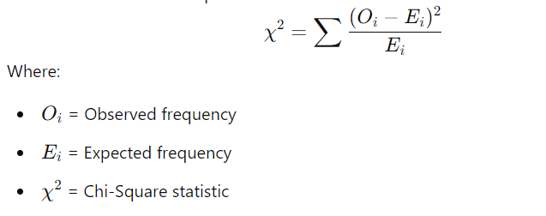

  - A larger difference between observed and expected frequencies results in a higher Chi-Square value, indicating a poor fit.
2. Test of Independence:
- Purpose: The Chi-Square test of independence determines whether there is a significant association between two categorical variables. It tests whether the occurrence of one variable is independent of the other.
- How It Works:
  - The test involves comparing the observed frequencies in a contingency table with the frequencies that would be expected if the variables were independent.
  - A significant Chi-Square value suggests that the variables are not independent and are associated with each other.
3. Conditions for Chi-Square Test:
- Random Observations: The data used in the test should be collected randomly to ensure unbiased results.
- Independence: The observations must be independent, meaning that the outcome of one observation does not affect another.
- Sufficient Sample Size: The sample size should be reasonably large, typically at least 50 observations. Additionally, each group should have a sufficient number of items, ideally not fewer than 10.
- Chi-Square as a Parametric Test: In cases where the test is used to assess population variance based on sample variance, the test assumes that the population variance is known. The formula in such cases is:
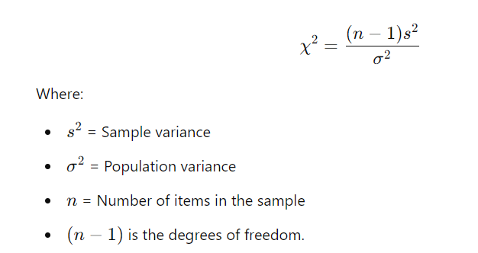
4. Interpretation:
- Chi-Square Value: The Chi-Square value reflects the difference between observed and expected frequencies. A larger value indicates a significant difference, leading to the rejection of the null hypothesis.
- Critical Value: The Chi-Square value is compared against a critical value from the Chi-Square distribution table, which is based on the degrees of freedom and the chosen significance level.
Summary:
The Chi-Square Test is an essential tool for testing the goodness of fit and the independence of variables. It compares observed and expected frequencies to determine whether any observed differences are statistically significant. The test's flexibility allows it to be used in various contexts, including testing population variance. Understanding the conditions and proper application of the Chi-Square Test ensures accurate and reliable results in hypothesis testing.

Unit 3

Explain the different types of database languages and their significance in dbms
1. Data Manipulation Language (DML)
- Purpose: DML is used to work with data that is already organized in a database. It allows users to access, insert, delete, and modify data.
- Key Operations:
  - Retrieve Data: Look up information stored in the database using commands like SELECT (e.g., SELECT * FROM Students WHERE Age > 20;).
  - Insert Data: Add new records to a table (e.g., INSERT INTO Students (ID, Name, Age) VALUES (1, 'John', 21);).
  - Delete Data: Remove records from a table (e.g., DELETE FROM Students WHERE ID = 1;).
  - Modify Data: Change existing data (e.g., UPDATE Students SET Age = 22 WHERE ID = 1;).
- Types of DML:
  - Procedural DML: Requires specifying both what data you need and how to retrieve it (e.g., using a loop to retrieve data).
  - Declarative DML (Non-Procedural DML): Requires only specifying what data you need, and the system determines how to get it (e.g., SQL’s SELECT statement).
- Significance: DML enables users to directly interact with data, allowing them to make queries (specific requests for information), insert new data, delete unnecessary data, and modify existing data as needed.
2. Data Definition Language (DDL)
- Purpose: DDL is used to define and describe the structure of a database, including the creation, modification, and deletion of database objects like tables, indexes, and schemas.
- Key Operations:
  - Create Database Objects: Defines the structure of tables, indexes, and other objects (e.g., CREATE TABLE Students (ID INT, Name VARCHAR(50), Age INT);).
  - Alter Database Objects: Modifies the structure of an existing object (e.g., ALTER TABLE Students ADD Gender CHAR(1);).
  - Drop Database Objects: Deletes a database object (e.g., DROP TABLE Students;).
- Significance: DDL allows for defining the organization of data and additional properties, like constraints (rules for data integrity). It specifies data storage methods and access techniques, ensuring efficient data management while hiding technical details from the user.
The DDL is also used to specify additional properties of the data.
Additional Properties and Constraints Defined in DBMS:
1. Consistency Constraints
- These are rules that ensure the database remains accurate and reliable. The most common types include:
  - Domain Constraints: Each attribute must contain values from a specific domain (e.g., a PhoneNumber field must only contain numeric values).
  - Referential Integrity: Ensures that data in one table corresponds with data in another. For instance, a CustomerID in an Orders table must match an existing CustomerID in the Customers table.
2. Assertions
- These are conditions that must always be true in the database. For example, an assertion could enforce that an employee’s salary is always greater than zero.
- Authorization.
We may want to differentiate among the users as far as the type of access they are permitted on various data values in the database. These differentiations are expressed in terms of authorization, the most common being: read authorization, which allows reading, but not modification, of data; insert authorization, which allows insertion of new data, but not modification of existing data; update authorization, which allows modification, but not deletion, of data; and delete authorization, which allows deletion of data
- State importance of each of these language
Data Definition Language (DDL)
- Importance:
  - Defines Database Structure: DDL provides the necessary commands to create and modify the structure of a database, such as tables, indexes, and relationships.
  - Organizes Data: It organizes data storage by specifying how data should be stored, accessed, and maintained, ensuring efficient database performance.
  - Enforces Data Integrity: DDL defines constraints like primary keys, foreign keys, and check constraints, ensuring the accuracy and consistency of the data.
  - Abstracts Technical Details: By defining the schema, DDL hides complex storage details from the user, allowing them to focus on higher-level tasks.
Data Manipulation Language (DML)
- Importance:
  - Facilitates Data Access: DML allows users to retrieve, insert, delete, and update data, making it easier to manipulate the stored information.
  - Enables Data Querying: Declarative DML enables users to interact with the data without worrying about how it's accessed or retrieved, making it user-friendly for non-technical users.
  - Allows Data Modifications: Through procedural or non-procedural methods, DML helps in efficiently modifying large datasets for analysis, reporting, or maintenance purposes.
  - Supports Transactional Operations: DML commands are used to manage day-to-day operations in the database, supporting the basic CRUD (Create, Read, Update, Delete) operations.

Give comparison of the different types of NoSQL databases with reference to their performance.

Explain different phases of data analytic life cycle.

Here is a brief overview of the main phases of the Data Analytics Lifecycle
Phase 1: Discovery
The first step where the team gets to know the business problem they are trying to
solve. They also check if the business has tried similar projects before and can learn
from them.
The team looks at the resources (like people, technology, time, and data) they have
and frames the problem in a way that data analytics can help solve. They also come
up with initial guesses (called hypotheses) about what the data might reveal.
Goal: Understand the problem and resources available.
Phase 2: Data Preparation
Getting the data ready to use for analysis.
The team creates a space (called a sandbox) where they can safely work with data.
They then bring in the data (using techniques like ETL, which stands for Extract,
Transform, Load), clean it, and organize it so it’s ready for analysis.
Goal: Make the data clean and accessible for analysis.
Phase 3: Model Planning
Deciding on how to analyze the data and which methods to use.
The team studies the data to see how different variables relate to each other. They then
choose the best variables and models to use for analysis in the next phase.
Goal: Plan the methods and models to be used.
Phase 4: Model Building
Actually creating the models to analyze the data.

The team prepares the data by splitting it into different sets (like training and testing
sets). They then build the models based on their earlier plan and test if their existing
tools can handle the job or if they need faster computers or better tools.
Goal: Build and test models to analyze the data.
Phase5: Communicate Results
Sharing the results with the business and stakeholders.
The team checks if their analysis solved the problem based on the success criteria
from Phase 1. They identify key findings, calculate the business value, and create a
report or presentation to share with stakeholders in a clear and simple way.
Goal: Share key insights and results with stakeholders.
Phase 6: Operationalize
Putting the solution into use in the real world.
The team delivers the final reports, code, and documentation, and sometimes runs a
small pilot project to see how the solution works in real-world settings. This phase
ensures the results are applied and monitored in the business.
Goal: Implement the solution and monitor its performance.

Explain database system architecture with neat diagram

The most commonly discussed database architecture is three-tier architecture
The main aim of three schema architecture is data independence. Data independence means users should not be able to interact with data directly. User should not be aware about the fact exactly data is stored. Data is physically present in database and there are three levels between user and database.

View Level: The job of view level is how to represent data to user. For ex: A student is trying to login to his college website using his/her credentials. Once he/she login then they will be able to see marks, attendance, fee structure etc. This is known as student view. This view will not be same for all users. Faculties, principal will have separate view. In short each and every user has separate view. Interface designers usually works at external schema level
Conceptual schema: The way in which data is represented. Basically we are concerned with structure of data for example if we have student data the we have columns in student data (RollNo, Name, Address). Database designers works at conceptual schema

Physical Schema: It specifies at which location data is stored. Database administrator decided at which location to store which data Database administrator works at physical level
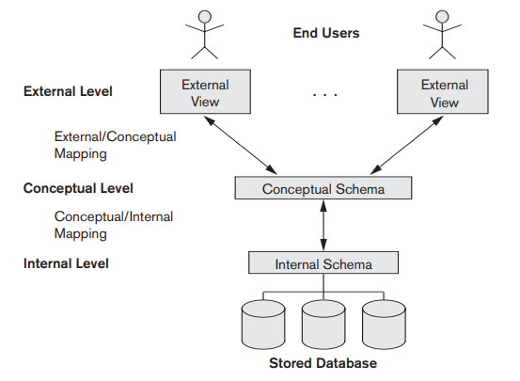

Tabulate features of SQL and noSQL database.

Explain the following database

Key value pair based
Designed for storing data in schema-less way. Data is stored as key-value pairs where each key is unique, and its corresponding value can be any type of data(eg: strings, numbers and even more complex objects). It is best for Fast data retrieval, caching, session storage, and simple data lookups. These types of databased are used for Storing user sessions in web applications.
Example: Cassandra, DynamoDB, Azure Table Storage etc

Column Oriented graph
A wide-column database is a type of NoSQL database in which the names and format of the columns can vary across rows, even within the same table. Wide-column databases are also known as column family databases.

Wide-column NoSQL databases still have the concept of rows, but reading or writing a row of data consists of reading or writing the individual columns. A column is only written if there’s a data element for it. Each data element can be referenced by the row key, but querying for a value is optimized like querying an index in a RDBMS, rather than a slow table scan.
It is used for handling large datasets, like logs, time-series data, or distributed data across many nodes.

Graph based
These databases are designed to store and manage data that is highly interconnected. Data is stored as nodes and edges, which represent entities and their relationships. It is best for Managing complex relationships, like social networks, recommendation engines, and fraud detection. It is used in Social media platforms where users, their connections, and interactions are analysed.
Example: Neo4j, Amazon Neptune

Document oriented
These databases store data as documents (typically in formats like JSON or BSON). Each document can have a flexible schema, allowing for varying structures of data within the same collection.
It is best for semi-structured data when flexibility is needed for the data model
It is widely used in product catalogs in e-commerce platforms where each product might have different attributes

Advantages of NOSQL database
1. Scalability
Horizontal Scaling: NoSQL databases are designed to scale horizontally across many servers, meaning they can handle massive amounts of data by adding more servers rather than upgrading a single powerful machine.
Benefit: This makes it easier and more cost-effective to handle growing datasets without major downtime or restructuring.
2. Flexibility in Schema
Dynamic Schema: NoSQL databases allow for a flexible, schema-less structure, meaning you don’t need to define the structure of your data upfront.
Benefit: You can easily modify the data structure on the fly, making it ideal for unstructured or semi-structured data like JSON or XML, where the format of data may evolve over time.
3. High Availability and Fault Tolerance
Built for Distributed Systems: NoSQL databases typically provide strong support for distributed systems, making them more resilient to failures.
Benefit: Data is often replicated across multiple nodes, ensuring that if one node fails, the system remains available.
4. Better Performance for Certain Use Cases
Optimized for Specific Workloads: NoSQL databases are often optimized for specific types of operations like fast reads and writes, especially with large datasets.
Benefit: This results in lower latency and faster performance, particularly for applications that require high-throughput operations, such as real-time data analytics, caching, and content delivery.
5.Handling Large Volumes of Data
Big Data-Friendly: NoSQL databases are well-suited for handling large volumes of unstructured or semi-structured data, such as social media posts, sensor data, logs, or multimedia content.
Benefit: This makes them ideal for modern big data applications like IoT, social networking, and recommendation systems.
6.Distributed Architecture
Data Distribution Across Servers: NoSQL databases are designed to distribute data across multiple servers or data centers.
Benefit: This ensures data redundancy, improved reliability, and the ability to handle geographically distributed users with lower latency.

7.Cost-Effectiveness
Low-Cost Hardware: NoSQL databases can run on clusters of inexpensive commodity hardware instead of relying on expensive, high-performance machines.
Benefit: This reduces the overall cost of infrastructure, especially as the system scales.
8.Support for Cloud and Modern Applications
Cloud-Ready: Many NoSQL databases are designed with cloud-native applications in mind and can easily integrate with cloud environments, allowing for automatic scaling and global data distribution.
Benefit: This makes them ideal for applications that need to serve users across different regions, with real-time availability.
9.Fast Development Cycle
Easier to Adapt: The flexible schema and ability to store complex data types (like JSON or XML) enable faster iteration in application development.
Benefit: You can quickly adapt to changing business requirements without complex database migrations.
10.Handling Diverse Data Types
Multi-Format Data Support: NoSQL databases can handle a wide variety of data formats, including structured, semi-structured, and unstructured data.
Benefit: This is particularly useful for applications that deal with multimedia, sensor data, documents, and other non-relational data.

Differentiate between SQL and NoSQL. How to decide which is relevant for project development? How to decide whether SQL or NoSQL is relevant for project development. 6 marks
No | SQL | NoSQL
1 | SQL are primarily called as relational databases | NoSQL database are primarily called as non-relational or distributed database
2 | SQL databases are table-based databases | NoSQL databases are document based, key-value pairs, graph databases or wide-column stores.
3 | SQL databases have predefined schema | NoSQL databases have dynamic schema for unstructured data.
4  5 | SQL databases are vertically scalable  SQL databases uses SQL (structured query language) for defining and manipulating the data | NoSQL databases are horizontally scalable.  NoSQL database, queries are focused on collection of documents. Sometimes it is also called as UnQL (Unstructured Query Language
6 | SQL database examples : MySql, Oracle, Sqlite, Postgres and MS-SQL. | NoSQL database examples : MongoDB, BigTable, Redis, RavenDb, Cassandra, Hbase, Neo4j and CouchDb
7 | SQL databases are good fit for the complex query intensive environment | NoSQL databases are not good fit for complex queries.
8 | SQL databases are not best fit for hierarchical data storage. | NoSQL database fits better for the hierarchical data storage as it follows the key-value pair way of storing data similar to JSON data
9 | SQL databases are best fit for heavy duty transactional type applications, as it is more stable and promises the atomicity as well as integrity of the data. | NoSQL for transactions purpose, it is still not comparable and stable enough in high load and for complex transactional applications.
10 | Uses ACID Properties | Uses CAP theorem

Choose SQL if your project needs:
- Structured, relational data with well-defined schemas.
- Complex queries, ACID compliance (strong consistency), and transactional support.
Choose NoSQL if your project requires:
- Handling large volumes of unstructured or semi-structured data.
- High scalability, flexibility in schema, and rapid read/write operations, with less emphasis on strict consistency.
Difference between structured and unstructured data:

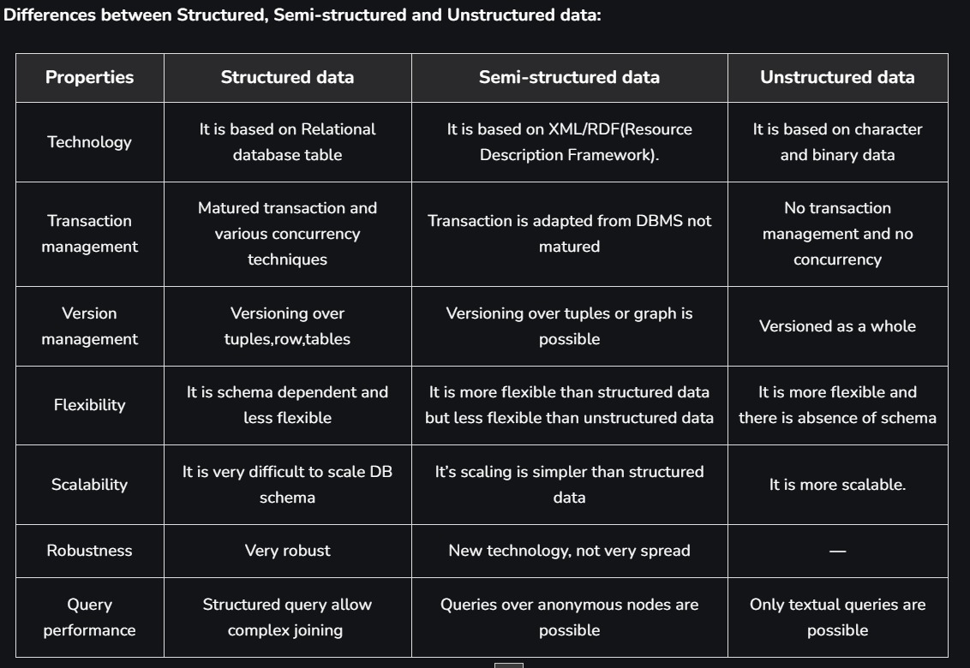
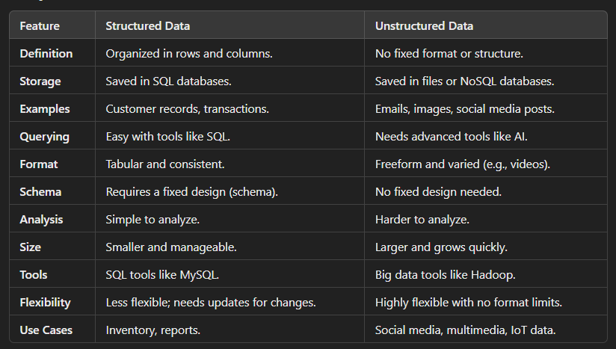

Unit 4
Perform the following operation in data frame:
i).Write a R program to add a new column in a given data frame.
ii). Write a R pr0gram to add new row(s) to an existing data frame.
iii).Write a R program to drop column(s) by name from a given data frame.
iv).Write a R program to drop row(s) by number from a given data frame.

x <- c(1, 2, 3, 4, 5)
y <- c(2, 4, 4, 6, 8)
frame <- data.frame(x, y)

# add new column
frame$z <- c(10, 20, 30, 40, 50)

# add new row
frame <- rbind(frame, data.frame(x=c(100), y=c(200), z=c(300)))

# remove column z
frame <- within(frame, rm(z))

# remove row 4
frame <- frame[-4,]

